SKILL WEEK 2

- To Analyze process abstraction, execute fork(), understand exec() family, analyze parent-child relationships, inspect process tree, practice system call tracing.

Task-1: Using a manual command understand the fork() and exec() system calls

- Inspecting the Process Tree (pstree)

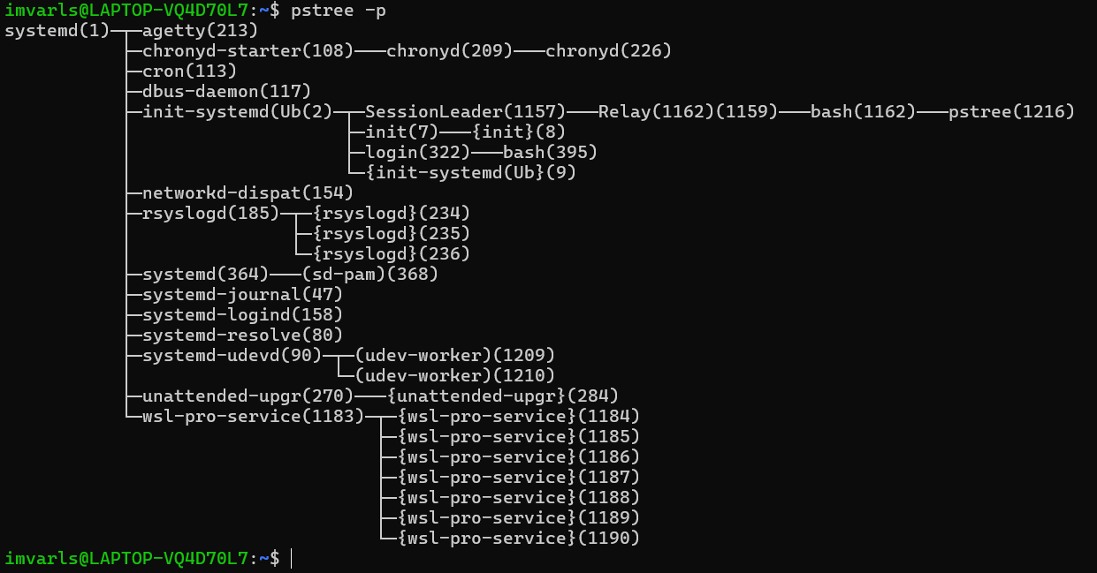

- System Call Tracing (strace)

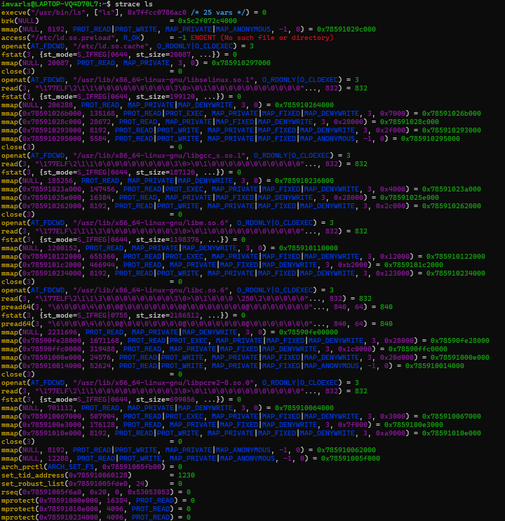

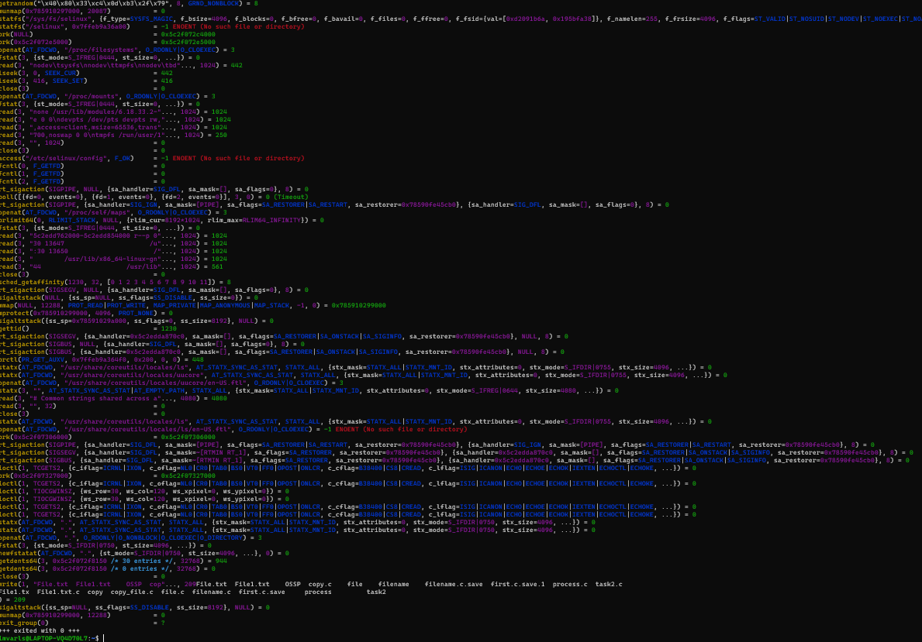

Task-2: Write a C program to create a new process and accepting the user commands using fork() and exec() system calls.

